Breathing Foam
The Breathing Foam is a symbol of connecting the rich history and state-of-the-art renewable energy technology in Denmark. Considering the proposed site locates in east seaside of the statue of the Little Mermaid. Breathing Foam interconnects the statue and the beautiful fair tale to promote the classic image of Copenhagen. Meanwhile, to educate visitors, to offer the shade for visitors, to offset green gas emission, to generate renewable energy, and to contribute to achieve Danish government’s climate policy and goals simultaneously, breathing foam applies bionic technique to mimic the real creature’s metabolism process to capture the maximum solar and wind power.
Reviewing the history
The Little Mermaid Statue is not only the icon of Copenhagen, but also a world-renown tourist attraction. The ideas of the Breathing Foam stem from this famous statue and aim to form a vivid and memorable image of the city accordingly.
Connecting the future
Danish government intends to establish a green power economic by applying 100% renewable energy in energy supply by 2050. The electronic system for the Breathing Foam consists of three individual systems: solar power generator system, wind power generator system, and CO2 reduction system. In the day, the Breathing Foam’s structure will be powered and stretched by themselves to orient to the sun and capture wind power. Besides, the membranes which intersect in windbelts will filter CO₂, and a dashboard on the post will show how much CO₂ has been filtered by this system. The top of the canopy would be installed with solar panels which are used to capture the solar power. In the night, the structures shrink and continue capturing the wind power and filter CO₂.
Materials and Environmental Impact
The Breathing Foam’s side structures are light weight but permanent structure mainly consisted by the Acrylic frame of the wind belt. The top of the structures are the Cassegrain Imaging Concentrator Mirrors. The whole structure is efficiently occupied by the green energy generation devices. The green energy will provide the surrounding area a new source of green power. More importantly, this site will be a perfect field for recreation and renewable energy education. With the installation of the Breathing Foam, this forgotten field will transform into a symbolic place announcing the arrival of a green age.
Technology Application:
- Wind Power
Wind Speed Data
Wind speed report Source:
DANISH METEOROLOGICAL INSTITUTE MINISTRY OF TRANSPORT
Observed Wind Speed and Direction in Denmark- with Climatological Standard Normals, 1961-90
Wind Data (1999):
Station: 30383 Avedøre
Position: lat 55° 38’ N, long 12° 26’ E
Elevation (m.a.s.l.): 8
Level of measurement: 10 m
Annual Wind Speed Range: 0.2m/s – 11m/s
0.2m/s -5.0m/s: 72.7%
5.0m/s – 11.0m/s: 25.7
Energy Technology: WindbeltTM
Technology Reference: Humdinger Wind Energy, LLC http://www.humdingerwind.com/#/home/
(Diagrams and basic technology data below are from this source)
Component Description:
The WindbeltTM is a technology that ‘using a tensioned membrane undergoing a flutter oscillation to pull energy from the wind.’
This technology makes use of an aerodynamic phenomenon called the aeroelastic flutter. The force that generated by this phenomenon brought down the Tacoma Narrow Bridge on November 7, 1940.
By flapped up and down by the wind, the membrane pulls energy from the wind and the module at both ends convert the energy into electricity.
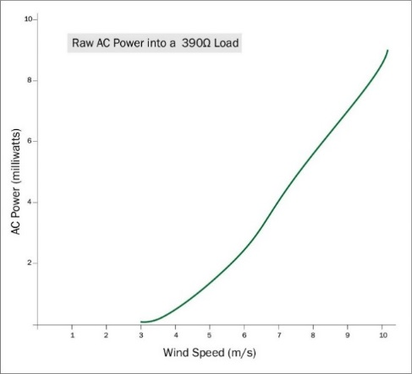
This technology is used as the major side frames of the Breathing Foam’s Structures in our design to capture wind power for operational use on the site and support the movement of the structure.
Micro
Size: 100cm * 3cm * 3cm
Wind Speed Range and Power Generation:
3.5 m/s 0.2 mW; 5.5 m/s 2.0 mW; 7.5 m/s 5.0 mW
Diagram from Humdinger Wind Energy, LLC
Operational Windspeed: 2.68 m/s – 8.94 m/s
Single Device Power Generation:
Medium
Wind Speed Range: 2.0m/s – 12.0m/s
Frequency of Oscillation 20-40 Hz
Single Device Power Generation: 0.1 kWh -1.0 kWh/Month
Integrate with Design:
Proposed Installed Structure Surface Area: 1714.748 m²
Purposed Installation Unit Quantity: 572
Single Unit = 6 Medium WindbeltTM
Single Unit Annual Capacity: 1.2 kW – 12kW
Single Structure Annual Capacity: 246 kW – 2460 kW
Total Annual Capacity: 688.8kWh – 6888kW
- Solar Power: Concentrated PV
Energy Technology: SolFocusTM
Technology Reference: SolFocus, inc. 2010 (Diagrams, photos and basic technology data below are from this source)
Description:
This technology using the Cassegrain Imaging Concentrator to direct sunlight onto a high efficiency solar cell to capture solar power.
A power unit is the basic unit of the SolFocusTM System. A power unit is a Receiver Unit surrounded by a Cassegrain Imaging Concentrator. Twenty power units are assembled side by side to form a CPV Panel. Then panels can be assembled as a CPV System.
The CPV System is the major component of the top of Breathing Foam’s structures. All the units will be installed facing the sky and forming a canopy against the sun. The canopy will be moved towards the sun to capture solar power as much as possible.
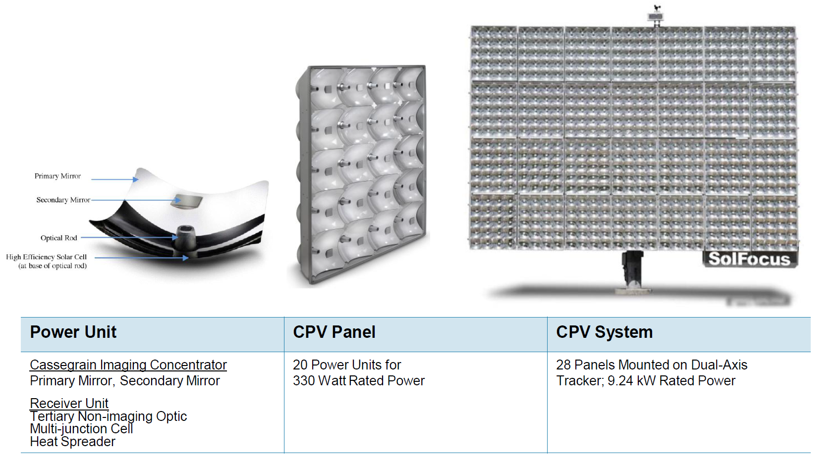
Photo from SolFocus, inc. 2010
Integrate with Design:
Proposed Installed Structure Surface Area: 1348.06 m²
Purposed Installation Power Unit Quantity: 14028
Single Unit Annual Capacity: 18.30kW
Total Annual Capacity: 256,659.84kW (256.66 MW)
- Reduce CO₂ Emission
Energy Technology: CO₂ Scrubbers by Dr Klaus Lackner, Director of the Lenfest Center for Sustainable Energy at Columbia University
Description:
All the structures of Breathing Foam integrate the CO₂ scrubbing machine that Dr Lackner designed to pull CO₂ from the air around to reduce CO₂ in its surroundings. The installation of CO₂ Scrubbers can absorb up to 331.09 kg CO₂ per year.

Overall Annual Capacity: 263,547.84kW (263.55 MW)
Overall Annual Embodied Energy Return by Generating Green Energy: 92.98 tonnes
(According CSIRO on embodied energy: Australia's foremost scientific institution http://www.csiro.au/org/CMSE)
Overall Annual CO₂ Absorption: 331.09 kg

