The three great elemental sounds in nature are the sound of rain, the sound of wind in a primeval wood, and the sound of outer ocean on a beach.
- Henry Beston
Inspiration

Ever since humans have walked upright, we have strolled among the trees of the forest, listening to the hidden symphony created as the primordial wind rustles the leaves in the canopy, watching as intense blades of light cut to the forest floor creating a radiant interaction amongst our wanderings in quiet contemplation. Myth and folklore have arisen from the natural interplay of light, shadow, and sound in the forest - this enriching tranquility has been a transformative experience throughout the ages.

This primal connection is still with us today. Studies show us the urban environment is improved and made more livable by the addition of trees. It is not only that their natural processes clean the air and sequester carbon, but people benefit from their presence both physiologically and psychologically – they literally make it easier to breathe, and they put the mind at ease. Growing urbanization has tended to disconnect humankind from nature, as trees are vastly outnumbered by homes, buildings and industrial infrastructure. Constrained by this reality and our need for energy, our collective intention grows to fuse the biophillic experience and urban infrastructure into harmony.

Wind Glade is bio-mimicry inspired public art that aims to connect people with natural cycles through the use of beauty, site context, and real time visual/audile feedback. The installation utilizes the structural form of a thicket rising from a glade. Passing through Wind Glade can evoke the feeling of walking through the trees. The experience can hopefully help visitors find a calm center while battling the challenges of urban life. Wind Glade provides an undulating canopy above, mimicking the wave form of wind and water, while also celebrating the wind through the sounds of meandering wind chime echo chambers. The entire thicket draws upon Copenhagen’s predominant natural energy source – Wind. The glade collects changing local winds and converts them into carbon free energy via an array of gradually elevated micro and macro turbines rising out of the canopy.

In the context of Copenhagen’s northern latitude, unique solar experience and limited annual sun exposure, Wind Glade’s overall space plan celebrates the summer solstice, the day of the year when the site will receive the most daylight. The central tree and open gathering space are positioned to encourage a clear view of sunrise and sunset on the solstice. Curved rows of trees and wind chime resonators radiate out from the open center space matching hourly positions of the sun for a 12-hour period on the summer solstice.

Technology/Materials

Canopy and Trees
The installation’s canopy structure is to be made primarily of recycled welded tubular steel organized in a bio-inspired voronoi lattice pattern. The lattice is supported and woven between major “trunks” which are large structural steel towers capped with a spiraling branch network of bar steel. Flowering and non-flowering vines will be planted at the base of the trunks, encouraging growth up the construction and into the canopy, providing shade, habitat, and shelter while sequestering carbon dioxide from the atmosphere.

Wind Chime Resonators
Sound resonators are suspended from the canopy at progressively changing heights inspired by a wave form. The tubes are made of hollow recycled aluminum and are clad in locally reclaimed ship wood ranging in length from 4 to 6 meters. Within the tubes, tuned chime bars create a range of tones. Electric solenoids ring the chimes and are controlled via a program that reads dynamic wind data. The sound array communicates information collected from the turbines creating ambient harmonies based on fluctuations in wind speed and direction. Low tones indicate low wind production with high tones representing elevated wind production based on real time wind behavior. The sounds of the array can also be computer controlled and played much like a carillon.

Wind Turbines
We will employ 120 1-meter diameter 400W micro-turbines and 6 medium size 10kW turbines scattered throughout the canopy lattice, along with one large turbine elevated out of the central “trunk”. The smallest turbine model is the Air Breeze, currently manufactured by Primus wind power. The medium is a Bergey Excel 10kW turbine. Both of these are well-established models with thousands of units in operation globally. The largest turbine is an Ogin 250kW which is a new type of shrouded turbine using a proprietary mixer/concentrator technology to improve wind energy outputs. Transformers, inverters and other control equipment can be housed in the hollow base of the “trunk” structures.

OLED Lights
The blades of the micro-turbines are embedded with OLED’s that change in color and light intensity. Shapes, letters, and numbers can be created digitally as the OLEDs are spun to relay real time data on wind speed, direction, and energy collection. The installation is capable of creating light shows fluctuating in brightness and hue with the behavior of the wind or simply mimicking the experience of gazing up through the branches of a forest at the star lit night sky.

Environmental Impact

It is expected this structure will not be energy intensive to make. By design Wind Glade will produce substantially more energy annually than required for its operation and can quickly offset its own lifecycle construction impact. An energy analysis shows it should recover the embodied energy required to create it within 2 years.

Studying historic average wind speeds and distributions, a typical wind speed for each turbine type and height was determined. It is expected that the small turbines will produce 100,000 kWh/year, the medium size turbines will produce 175,000 kWh/year, and the large turbine will produce 1,100,000 kWh/year. In total 1.25-1.5 million kWh/year will be produced - enough to power 250-350 Danish homes, depending on wind speed, and annual wind variability.

The annual kilowatt-hours generated by Wind Glade, in addition to the vegetation growing on the towers and canopy, represents approximately 1000 metric tons of carbon dioxide offset from fossil fuel production.

Real world testing has shown that wind turbines are not a significant danger to birds, however, Wind Glade takes extra steps to employ bird safety design. The large and medium turbines have low RPMs which will decrease danger to avian species. The small turbines have low blade speeds, and very small swept areas. The embedded OLED lights will further help the birds recognize and avoid the spinning blades making it appear as though the turbines are a solid object.

Using recycled, locally reclaimed, and repurposed materials, we hope to mitigate much of the negative impact and carbon costs of the structure as a whole.

Appendix 1: Energy production and usage

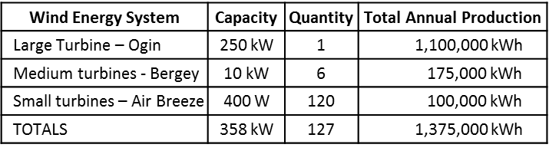
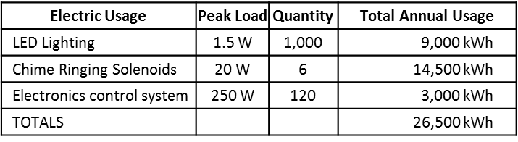
Appendix 2: Chime Ringing Solenoid Diagram

