SN270469 - #HelioTweet
'A short burst of inconsequential information' – Jack Dorsey, the first tweet
The installation is made up of 140 "characters" - each "character" is a solar tracking (Heliotropic) photovoltaic system - the PV panel set out is used to form a seven segment display within a 7.5m x 9m module (67.5m2).
The overall array size is therefore 140 x 67.5 = 9450m2

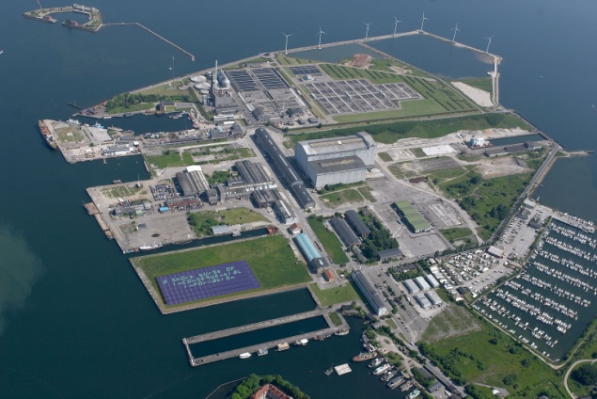
The seven segment display is seen here as the graphic language of carbon - it is the very typeface symbolic of fossil fuel consumption, from the gas pump to the forecourt fuel price totem.
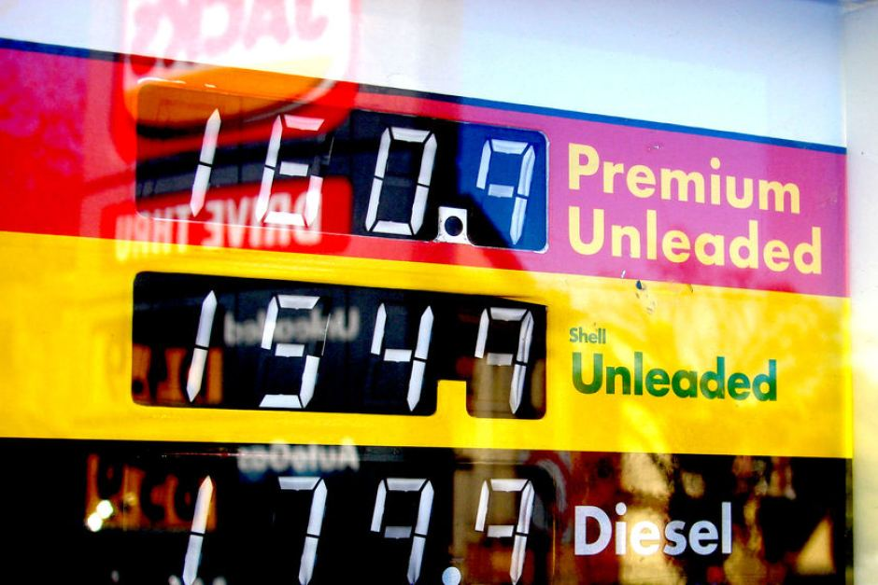
It is envisioned that the feed from the installation’s dedicated twitter account will be primarily focused on climate issues. This is a canvas to explore many applications/ functions/ outputs – such as atmospheric CO2 concentration as demonstrated – 401 ppm (as of 17/05/14)
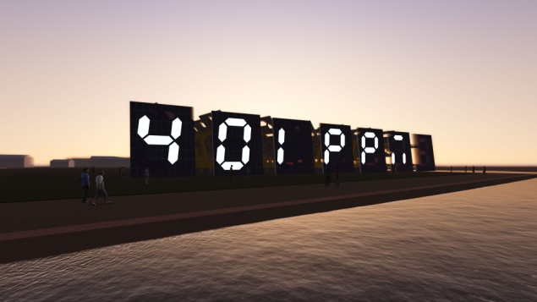
Laminated into each of the display panel glazed segments is a switching film – consisting of Polymer Dispersed Liquid Crystals (PDLCs) - which is used to control the opacity of each of the segments, and light tape - http://www.lighttape.com/ - is used to illuminate the segment.
The Hydraulic arms of the "characters" are based on those of earth working excavators, they would be slow moving and driven by the arrays (if possible they would be repurposed digger arms) – these bring an industrial aesthetic appropriate to the site and speak of resource extraction.

#EcoGlyph
In the land art tradition of geoglyphs and hillside letters.... from the Nazca Lines of Peru to the Hollywood sign .... This is an attempt to take an established contemporary architype with a heritage spanning back to prehistory and reimagine it in a context relevant to the pressing concerns of the times - to make art from renewable energy ....
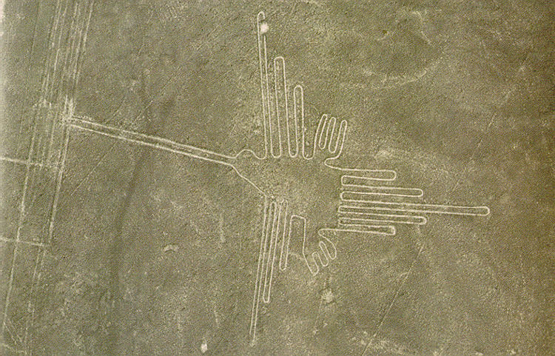
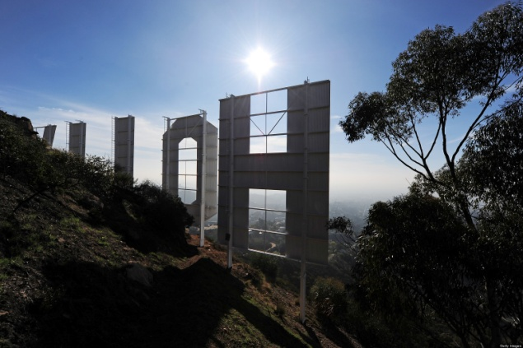
Balance of System (BoS)
The balance of system or BoS encompasses all components of a photovoltaic system other than the photovoltaic panels. This includes wiring, switches, support racks, an inverter, and batteries in the case of off-grid systems. In the case of free-standing systems, land is sometimes included as part of the BoS.
Multi-axis tracking in the Copenhagen latitude enables a projected 22% increase on energy output. The #HelioTweet installation is a celebration of this dynamic response to the sun’s path throughout the year.
This is an exploration into finding added value in the BoS - this added value creates art but this can be seen very much as an art that opens up potential revenue streams that then drive down the BoS cost further.
#SocialSolar
This is an investigation into ways to "inhabit" the "BoS space" - drawing out utility/revenue from traditionally under-utilised aspects of a commercial scale photovoltaic system.
Sun tracking will maximise solar harvesting but the "characters" have the potential for many configurations and dynamic movements. When the sun isn't shining why not find some use/ fun/revenue...
Re:Venue
• Music | • Events
• Weddings | • Festivals
• Raves | • Fashion
• Exhibitions | • Art

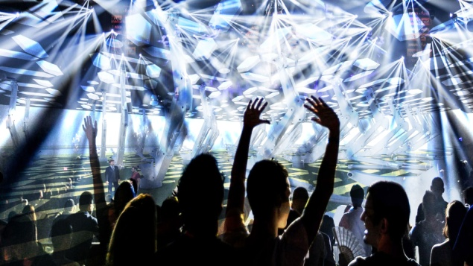
The #HelioTweet is seen as having the potential to act as a reimagined "speaker's corner" - an installation where analogue and digital meet, encouraging freedom of thought/expression.
Is it censored, monitored, sponsored?
A debate we look forward to having ...
Energy Calculations
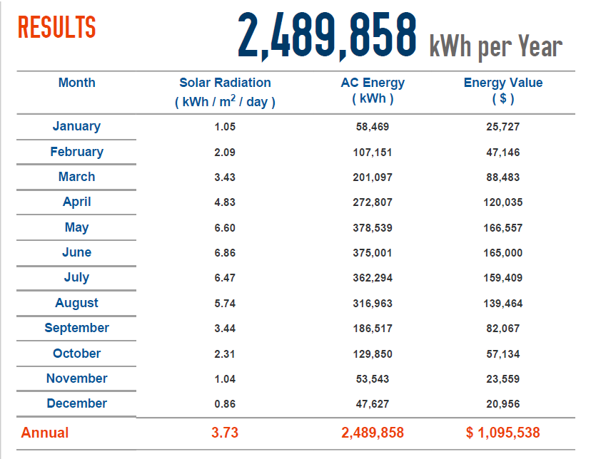
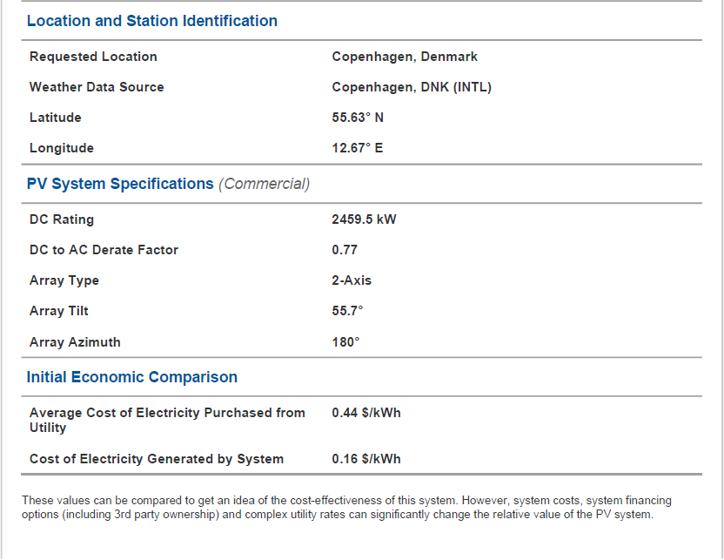
Photovoltaic system performance predictions calculated using PVWatts® developed by NREL (National Renewable Energy Laboratory):

